Customer | NOKIA
Product PN | ALC3H-8DG60959ABAB_N
Product Description | PBA 100G SD FEC LINE DAUGHTER BOARD
Product SN | ST191750278
Repair ID | GERTS089789 / ST193650249

Date of issue: 10.DECEMBRIE.2021
Product details:

Component details:
Material PN | ALC3-1AB227640008_REP
Material Description | OBELIX 100
Material SN or Lot Nr | N/A
Date Code or Part Mark | N/A
Supplier Name | ALTERA
Supplier PN/MPN | EP4S100G5H40I1N

- Problem description: U9003 (1AB227640008) defective component

- Detected by: Customer field failure, failure confirmed by factory tests

- Quantity Affected: 1 PCS
- Failure Message: Signal Degrade Egress - ODU on PORT C1 at 25C
- Flex or Nokia analysis:
This unit failed in field at customer with “Signal Degrade Egress - ODU on PORT C1 at 25C” failure. Flex factory test confirmed this failure: Bit Errors from SSY at C1, pack works fine in Client Facility Loopback (with only client side active) but not in Client Far Loopback (client+obelix loopback). U9003 (1AB227640008) defective component.
Replacing the component solved the problem and card passed factory tests.

- Component Physical Condition:

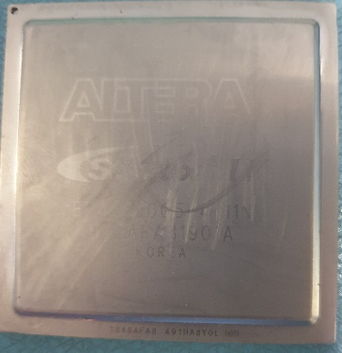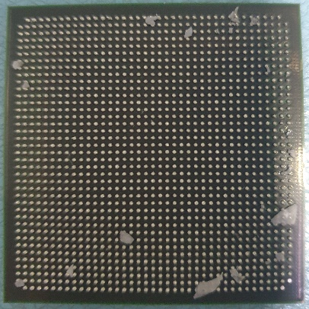

7.Containment Plan

- Inspection mode: N/A
- Acceptable criteria: N\A
- Re-action: N\A
- Observation: The pins on the component are missing.
- Inform component supplier about this problem
- Supplier should investigate the cause of the failure

