Customer | NOKIA
Product PN | ALC3H-8DG60959AAAE_N
Product Description | PBA 100G SD FEC LINE DAUGHTER BOARD
Product SN | EZ1603B1328
Repair ID | GERTS093410; EZ162232614

Date of issue: 21.SEPTEMBRIE.2021
Product details:

Component details:
Material PN | ALC3-1AB227640008_REP
Material Description | OBELIX 100
Material SN or Lot Nr | CDFAG1549A
Date Code or Part Mark | N/A
Supplier Name | ALTERA
Supplier PN/MPN | EP4S100G5H40I1N

- Problem description: U9003 (PN: 1AB227640008) defective

- Detected by: Customer field failure, failure confirmed by factory tests

- Quantity Affected: 1 PCS
- Failure Message: “8mff on asterix Client Chennel =0 and 8mff on astrix Client channel = 1”
- Flex or Nokia analysis:
This units failed in field at customer with “ 8mff on asterix Client Chennel =0 and 8mff on astrix Client channel = 1” error. Flex factory test confirmed this error: Doing the loop back CLNL at internal of obelix the alarms are not detected, instead doing the loop back CLML at internal the obelix the alarms are detected.

Replacing the component solved the problem and card passed factory tests.

- Component Physical Condition:

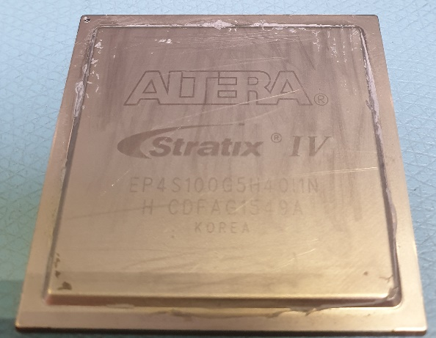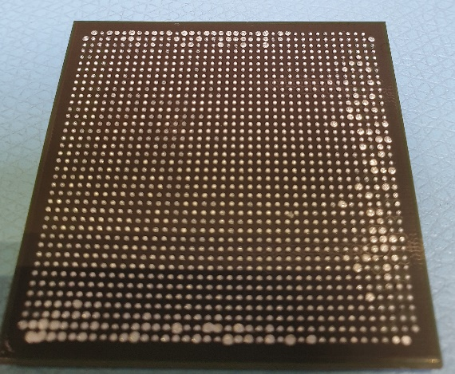

7.Containment Plan

- Inspection mode: N/A
- Acceptable criteria: N\A
- Re-action: N\A
- Observation: The pins on the component are missing.
- Inform component supplier about this problem
- Supplier should investigate the cause of the failure

