Customer | NOKIA
Product PN | ALC3H-8DG62058BAAB
Product Description | NUBCM
Product SN | RT203703833
Repair ID | RMA2021-0031 /RT4510557

Date of issue: 27.SEPTEMBRIE.2021
Product details:

Component details:
Material PN | ALC3-1AB425040001_REP
Material Description | ICFPGA5CSXFC6C6U2317MCyclone5BGA/672333-I/O110-40C/100C
Material SN or Lot Nr | N/A
Date Code or Part Mark | N/A
Supplier Name | ALTERA
Supplier PN/MPN | 5CSXFC6C6U23I7N

- Problem description: FPGA U1 (ALC3-1AB425040001) load failed

- Detected by: Customer field failure, failure confirmed by factory tests

- Quantity Affected: 1 PCS
- Failure Message: “Card failure-communication”
- Flex or Nokia analysis:MISSING PINS
This card failed at customer with no boot issue.
The nUBCM card failed at Prescreening test with “Card failure-communication” error. The failure is caused by FPGA U1 load failure and keeps repeating the load failure message continuously.
Replacing the component solved the problem and card passed factory tests.

Replacing the component solved the problem and card passed factory tests.

- Component Physical Condition:

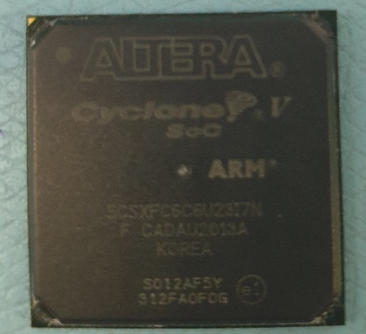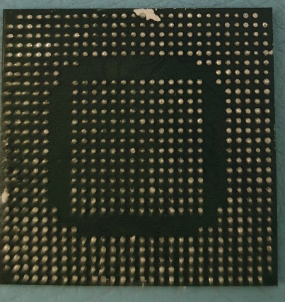

7.Containment Plan

- Inspection mode: N/A
- Acceptable criteria: N\A
- Re-action: N\A
- Observation: The pins on the component are missing.
- Inform component supplier about this problem
- Supplier should investigate the cause of the failure

