Image without BSP Editor:
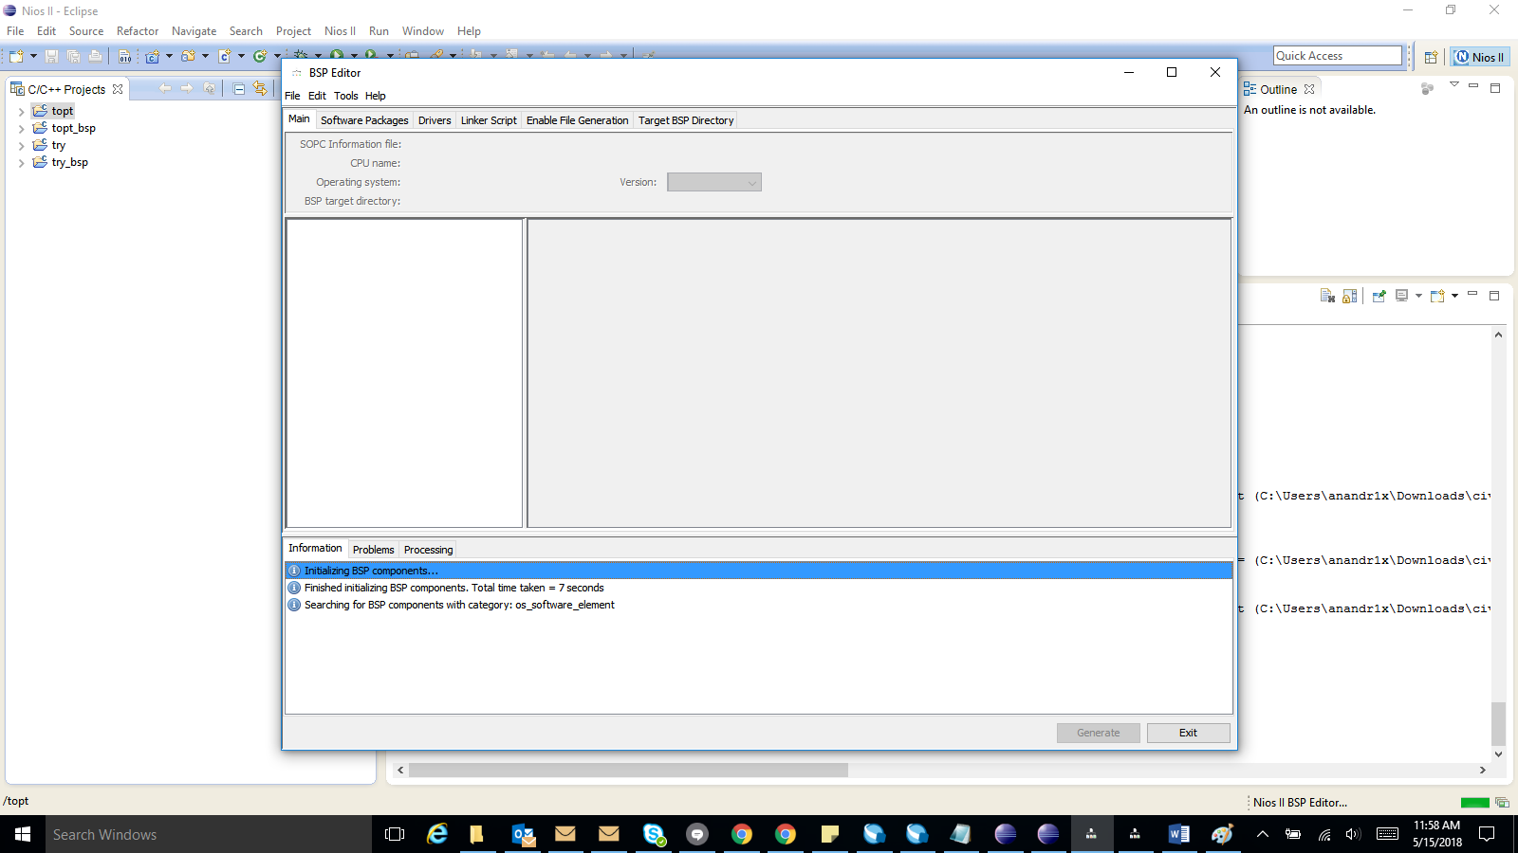
Image with BSP Editor:
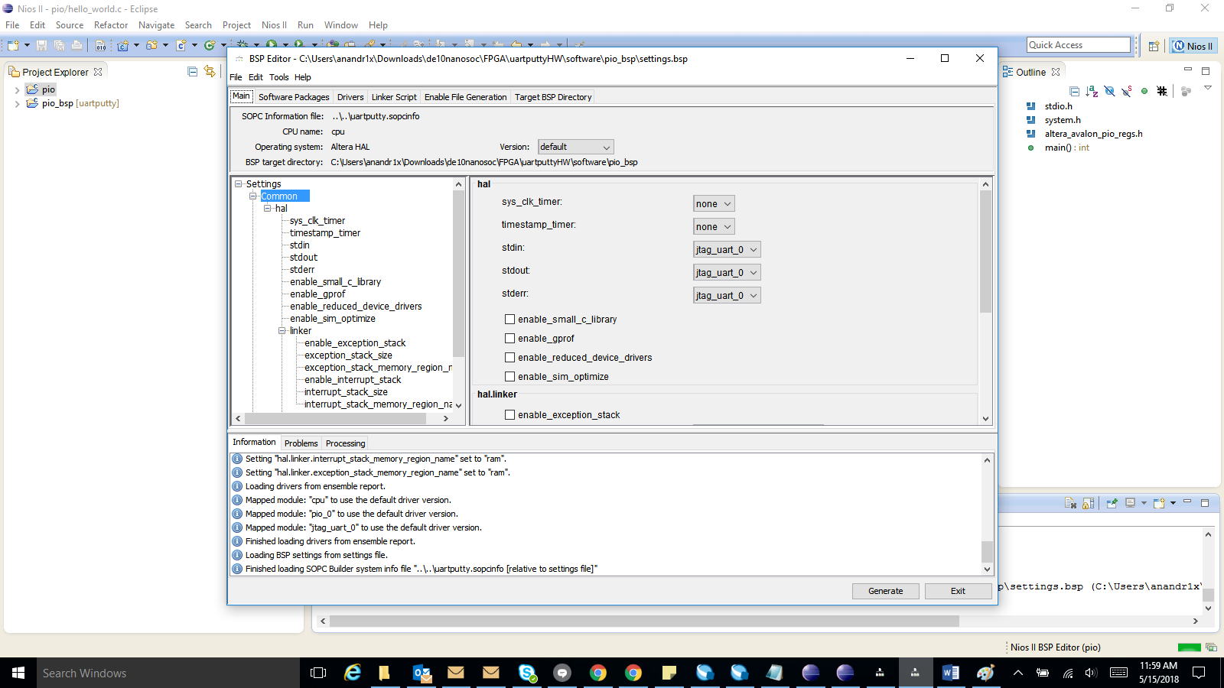

Steps: Go to File-> new BSP
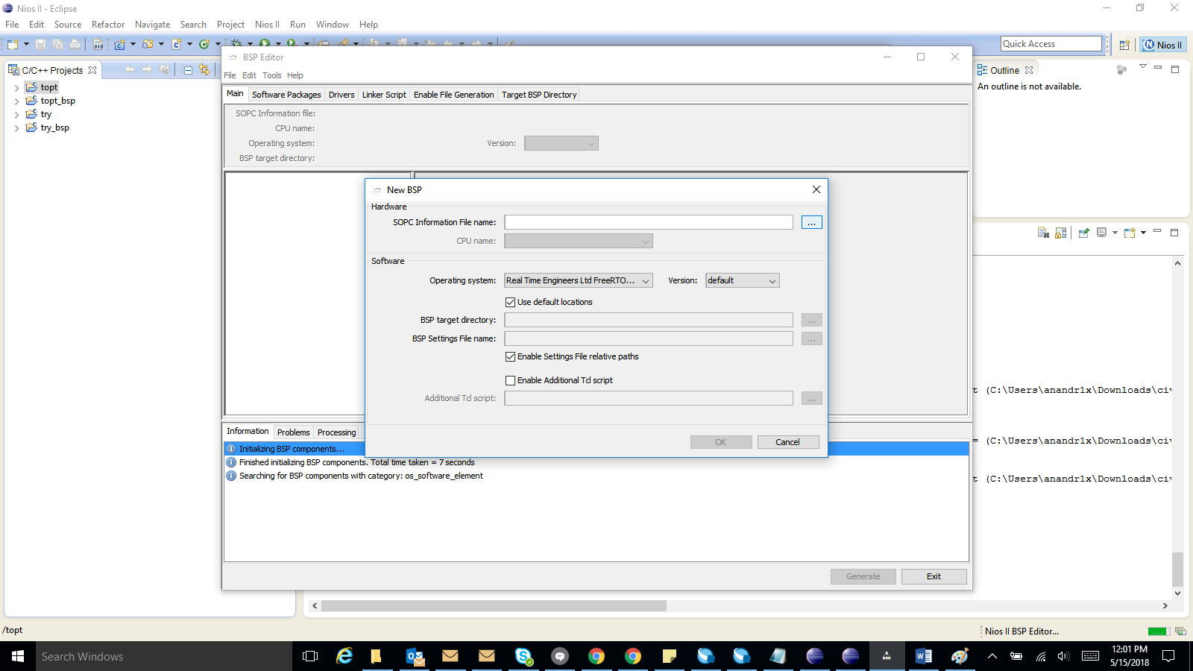
Step 2: Select the .sopcinfo file and set Operating system=>Altera hal.
And follow the steps from video.

